COMBUSTION TECHNOLOGY

Aim of laboratory practice:
Investigation of gas-fired household combined heating and water heating equipment:
- Energy test of combustion apparatus (efficiency, flue gas loss)
- Environmental test of combustion apparatus (composition of flue gas)
In some sense, natural gas can be a renewable resource. A major plus of natural gas is that it can be efficiently and safely stored.
Natural gas is the cleanest burning fossil fuel. The combustion process for natural gas is almost perfect, very few byproducts are emitted into the atmosphere as pollutants. Also, with the introduction of new technologies, nitrogen oxide, a pollutant targeted by the Clean Air Act can be significantly reduced. The blue flame seen when natural gas is ignited is a sign of perfect combustion.
Natural gas is convenient. The energy source is piped directly to the customer's facility through the safe, efficient pipeline system. There's no need to store oil on site in tanks, or schedule oil deliveries.
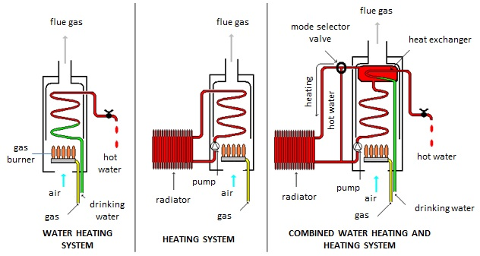
Fig.1. Conceptual structure of household hot water and heating energy production equipment

Most cases, the heat transfer fluid is water. Favorable properties:
- non-flammable,
- high specific heat capacity,
- cheap.
Types of combustion equipment: traditional and condensation. The condaensation equipments have higher efficiency (+condensation heat of water vapor from flue gas), but more expensive.

1. Basics of combustion technology:
The following processes take place during of methane combustion:
C + O₂ + ($\frac{\text{79}}{\text{21}}$ O₂ number of moles) N₂ = CO₂ + ($\frac{\text{79}}{\text{21}}$ O₂ number of moles) N₂
2H₂ + O₂ +($\frac{\text{79}}{\text{21}}$ O₂ number of moles) N₂ = 2H₂O + ($\frac{\text{79}}{\text{21}}$ O₂ number of moles) N₂
S + O₂ + ($\frac{\text{79}}{\text{21}}$ O₂ number of moles) N₂ = SO₂ + ($\frac{\text{79}}{\text{21}}$ O₂ number of moles) N₂
The combustion equipment usually has closed combustion chamber, so the flue gas loss is lower (~2%).
Misdirected process energy loss and/or environmental pollution:
- soot: carcinogenic,
- carbon monoxide: toxic,
- nitrogen oxides: ground-level ozon (toxic),
- hydrocarbons: greenhouse effect.
Solution: appropriate excees air factor and appropriate temperature of combustion chamber.

2. Combustion calculations:

2.1 Theoretical combustion air quantity (L₀)

L₀ (Nm³/Nm³) = necessary air quantity (Nm³) for complete combustion of 1 Nm³ fuel. If the natural gas contains only methane:
CH₄ + 2O₂ + ($\frac{\text{79}}{\text{21}}$ O₂ number of moles) N₂ = CO₂ + 2H₂O + ($\frac{\text{79}}{\text{21}}$ O₂ number of moles) N₂

2.2 Theoretical dry flue gas (V₀^{d})
Theoretical wet flue gas contains carbon dioxid, sulfur dioxid, nitrogen.
$$V_{0^{d}}={\text{CO}}_{2}+{\text{SO}}_{2}+N_{2}\left[\frac{{\text{Nm}}^{3}}{{\text{Nm}}^{3}}\right]$$
If the natural gas contains only methane:
$$V_{0^{d}}={\text{CO}}_{2}+N_{2}\left[\frac{{\text{Nm}}^{3}}{{\text{Nm}}^{3}}\right]$$

2.3 Theoretical wet flue gas (V₀^{w})
Theoretical wet flue gas contains water vapor, carbon dioxid, sulfur dioxid, nitrogen.
$$V_{0^{w}}={\text{CO}}_{2}+{\text{SO}}_{2}+H_{2}O+N_{2}\left[\frac{{\text{Nm}}^{3}}{{\text{Nm}}^{3}}\right]$$
If the natural gas contains only methane:
$$V_{0^{w}}={\text{CO}}_{2}+H_{2}O+N_{2}\left[\frac{{\text{Nm}}^{3}}{{\text{Nm}}^{3}}\right]$$

2.4 Excess air factor (n)

$n=\frac{L}{L_{0}}\left[\frac{{{\text{Nm}}^{3}}/{{\text{Nm}}^{3}}}{{{\text{Nm}}^{3}}/{{\text{Nm}}^{3}}}\right]$ or simplified:
$n=\frac{\text{21}}{\text{21}−O_{2\text{measured}}}$ or more specifically:
$n=1+\left[\frac{V_{0^{d}}}{L_{0}}⋅\frac{O_{2\text{measured}}}{\text{21}−O_{2\text{measured}}}\right]$

2.5 Actually produced (real) flue gas quantity (V^{d}, V^{w})
Real flue gas quantity > Theoretical flue gas quantity
Reason: n

Real dry flue gas:
$V^{d}=V_{0^{d}}+L_{0}\left(n−1\right)$ $\left[{\text{Nm}}^{3}{\text{Nm}}^{3}\right]$

Real wet flue gas:
$V^{w}=V_{0^{w}}+L_{0}\left(n−1\right)$ $\left[{\text{Nm}}^{3}{\text{Nm}}^{3}\right]$

2.6 Boiler efficiency (thermic efficiency) ($η$)
Calculation of direct efficiency:
$η\left[\text{\%}\right]=\frac{G⋅c_{v}⋅\left(t_{2}−t_{1}\right)}{\text{Fé}⋅\text{Vg}}\text{100}$
G – volume of boiler inlet water $\left[m^{3}h\right]$
t₂ és t₁ – temperature of boiler outlet and inlet water $\left[oC\right]$
c_{v} – specific heat of water 4186,8 $\left[\text{kJ}m^{3 o}C\right]$
Fé – heating value of gas 34000 $\left[\text{kJ}{\text{Nm}}^{3}\right]$
Vg – volume of gas $\left[{{\text{Nm}}^{3}}/h\right]$

Calculation of indirect efficiency:
$$η=\text{100}−\left(Q_{f}+Q_{\text{CO}}+Q_{s}\right)$$
Q_{f} – flue gas loss $\left[\text{kJ}{\text{Nm}}^{3}\right]$
Q_{CO} – loss of imperfect combustion $\left[\text{kJ}{\text{Nm}}^{3}\right]$
Q_{s} – radiation loss $\left[\text{kJ}{\text{Nm}}^{3}\right]$

2.7 Flue gas loss (Q_{f})
$Q_{f}=\frac{V^{w}⋅c_{f}⋅(t_{f}−t_{\text{air}})}{\text{Fé}}⋅\text{100}\text{\%}$$\left[\text{\%}\right]$
cf – heating value of flue gas 1,35$\left[\text{kJ}m^{3o}C\right]$
t_{f} – temperature of flue gas $\left[oC\right]$
t_{air} – temperature of inlet air $\left[oC\right]$
Fé – heating value of gas $\left[\text{kJ}{\text{Nm}}^{3}\right]$
3. Laboratory equipment:
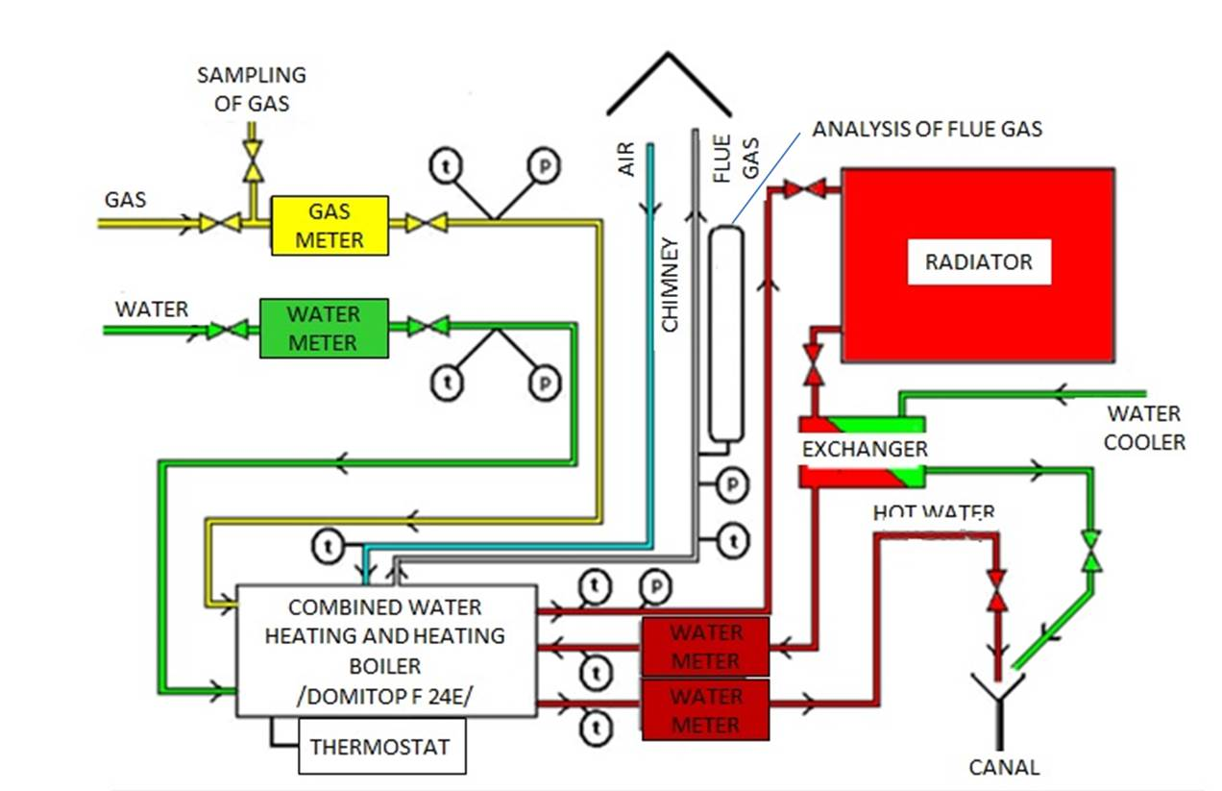
Fig.2. Schematic diagram of equipment

Combustion equipment: FERROLI Domitop F 24 E (24 kW)
- combined water heating and heating boiler
- traditional, not condensation boiler
- gas-fired
- closed combustion chamber
- with flue gas blower
- with coaxial chimney (flue gas + combustion air)

Flue gas analyser: TESTO 330
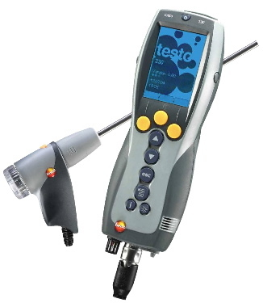
- exceed air factor: n (λ)
- efficiency: η [%]
- temperature of combustion air: T_{lev}
- temperature of flue gas: T_{f}
- concentration of CO, NO_{x}
- O₂%

Process of laboratory measurement:
- Open water and gas valve.
- Turn on (ON) combustion equipment.
- Open cooling water.
- Adjust the thermostat (30°C).
- Record values of gas and water meter, temperatures every 5 minutes.
- End of the measurement when inlet and outlet water temperature points on steady state level (min. 3 points)
- Analysis flue gas with TESTO 330 (O_{2,} CO, NO_{x}, n, η, T_{lev}, T_{f})
- Finish measurement, turn off (OFF) combustion equipment, close water and gas tap.

Measuring diary:
- Short theory
- Table of measurement data
- Schematic diagram of equipment
- Calculations (L_{o,} V_{o}^{d}, V_{o}^{w}, n, V^{d}, V^{w}, $η$, Q_{f}), results.

Measurement log

Date: Location: FII. 2.floor 5. Name:
Heating system
Time |  | Gas  meter  [m³] | Gas pressure  [mbar] | Temperature of combustion air [ºC] | Temperature of flue gas  [ºC] |  | Composition of flue gas |  |  | Water meter  [m³] | Temperature of water
[hour] | [min] |  |  |  |  |  | O₂  [%] | CO [ppm] | NO_{x} [ppm] | Water meter  [m³] | boiler  inlet [ºC] | boiler  outlet [ºC]
Pressure [mbar]: |  |  |  |  |  | Temperature of gas [ºC]:
Termic efficiency (η, %): |  |  |  |  |  | n=λ:

